Les08-Set Operators



Objectives

# Describe Set Operators

# Use set operators to combine multiple queries into a single query

# Control order of rows returned

Topics Covered

Set Operator Types and rules

Tables Used in the lesson

UNION

UNION ALL

INTERSECT

MINUS

Matching SELECT statements

ORDER BY with set operators

Types - Union

UNION

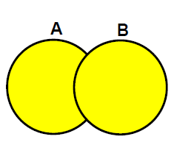

UNION of all the rows in A

With ALL the rows in B

With NO DUPLICATES

Types – Union All

8-4

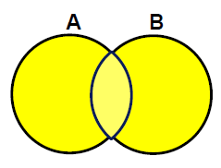

UNION of ALL the rows in A and B including duplicates

Types – Intersect

INTERSECT

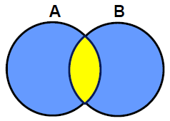

The rows in common to both tables only

A intersect B

same as

B intersect A

Types – Minus

8-4

MINUS

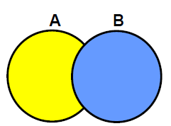

Rows in the first query A

That are not in second query B

PRECEDENCE – equal – evaluated left to right

Caution recommended. Use brackets with INTERSECT

Rules or Guidelines

8-5

- The expressions in the SELECT lists must match in number.

- If you select 3 columns in A, then must have 3 columns in B

- The data type of each column in the second query must match the data type of its corresponding column in the first query.

- Parentheses can be used to alter the sequence of execution.

- ORDER BY clause can appear only at the very end of the statement.

Other

• Duplicate rows are automatically eliminated except in UNION ALL.

• Column names from the first query are the ones that appear in the result.

• The output is sorted in ascending order by default except in UNION ALL.

Tables Used

8-8

Job_History

SQL> SELECT * FROM job_history;

EMPLOYEE_ID START_DAT END_DATE JOB_ID DEPARTMENT_ID

----------- --------- --------- ---------- -------------

102 13-JAN-93 24-JUL-98 IT_PROG 60

101 21-SEP-89 27-OCT-93 AC_ACCOUNT 110

101 28-OCT-93 15-MAR-97 AC_MGR 110

201 17-FEB-96 19-DEC-99 MK_REP 20

114 24-MAR-98 31-DEC-99 ST_CLERK 50

122 01-JAN-99 31-DEC-99 ST_CLERK 50

200 17-SEP-87 17-JUN-93 AD_ASST 90

176 24-MAR-98 31-DEC-98 SA_REP 80

176 01-JAN-99 31-DEC-99 SA_MAN 80

200 01-JUL-94 31-DEC-98 AC_ACCOUNT 90

**10 rows selected**. 🡸🡸

Records start date and end date of employees that switch jobs

Employees who are still in the same job will not appear here

Employees

SQL> SELECT employee_id, job_id, department_id

2 FROM employees;

EMPLOYEE_ID JOB_ID DEPARTMENT_ID

----------- ---------- -------------

100 AD_PRES 90

101 AD_VP 90

102 AD_VP 90

103 IT_PROG 60

104 IT_PROG 60

107 IT_PROG 60

124 ST_MAN 50

141 ST_CLERK 50

142 ST_CLERK 50

143 ST_CLERK 50

144 ST_CLERK 50

149 SA_MAN 80

174 SA_REP 80

176 SA_REP 80

178 SA_REP

200 AD_ASST 10

201 MK_MAN 20

202 MK_REP 20

205 AC_MGR 110

206 AC_ACCOUNT 110

**20 rows selected**.🡸 🡸

UNION

8-14

SELECT employee_id, job_id

FROM employees

UNION

SELECT employee_id, job_id

FROM job_history;

EMPLOYEE_ID JOB_ID

----------- ----------

100 AD_PRES

101 AC_ACCOUNT

101 AC_MGR

101 AD_VP

102 AD_VP

102 IT_PROG

103 IT_PROG

104 IT_PROG

107 IT_PROG

114 ST_CLERK

122 ST_CLERK

124 ST_MAN

141 ST_CLERK

142 ST_CLERK

143 ST_CLERK

144 ST_CLERK

149 SA_MAN

174 SA_REP

176 SA_MAN

176 SA_REP

178 SA_REP

200 AC_ACCOUNT

200 AD_ASST

201 MK_MAN

201 MK_REP

202 MK_REP

205 AC_MGR

206 AC_ACCOUNT

**28 rows selected**. 🡸 Why 28 rows

There are duplicates and were removed

20 rows + 10 rows – less 2 duplicates 🡺 28

To see the duplicates have to use UNION ALL

UNION ALL

8-16

Duplicate rows not eliminated

Output not sorted

Fasted – since no sorting

**SELECT employee_id, job_id**

**FROM employees**

**UNION ALL**

**SELECT employee_id, job_id**

**FROM job_history**

**ORDER BY employee_id;**

EMPLOYEE_ID JOB_ID

----------- ----------

100 AD_PRES

101 AD_VP

102 AD_VP

103 IT_PROG

104 IT_PROG

107 IT_PROG

124 ST_MAN

141 ST_CLERK

142 ST_CLERK

143 ST_CLERK

144 ST_CLERK

149 SA_MAN

174 SA_REP

176 SA_REP

178 SA_REP

200 AD_ASST

201 MK_MAN

202 MK_REP

205 AC_MGR

206 AC_ACCOUNT

102 IT_PROG

101 AC_ACCOUNT

101 AC_MGR

201 MK_REP

114 ST_CLERK

122 ST_CLERK

200 AD_ASST

176 SA_REP

176 SA_MAN

200 AC_ACCOUNT

30 rows selected. 🡸🡸 **20 rows + 10 rows**

Shows 2 duplicates

What if a big file 🡺 need to ORDER BY to make it easier to see

Try this

SELECT employee_id, job_id, department_id

FROM employees

UNION ALL

SELECT employee_id, job_id, department_id

FROM job_history

ORDER BY employee_id;

-- 30 rows

VS

SELECT employee_id, job_id, department_id

FROM employees

UNION

SELECT employee_id, job_id, department_id

FROM job_history

ORDER BY employee_id;

-- 29 rows – eliminated a duplicate

-- see employee 176 which is the duplicate

INTERSECT

8-19

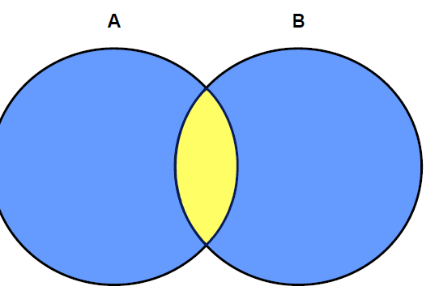

SELECT statements must be identical in number and data type

They do not have to be the same name

Reversing the order of the tables has no effect on the result

Finds the intersection of the two queries – what they have in common

EXAMPLE:

Display employee and job ids for those employees who currently hold the same job as when they were initially hired

i.e. Have gone back to their original job

**SELECT employee_id, job_id**

**FROM employees**

**INTERSECT**

**SELECT employee_id, job_id**

**FROM job_history;**

Results

Emp# Job Title

---------- ----------

176 SA_REP

200 AD_ASST

NOTE: Add the column department_id and 200 won't appear because department is different

MINUS OPERATOR

8-22

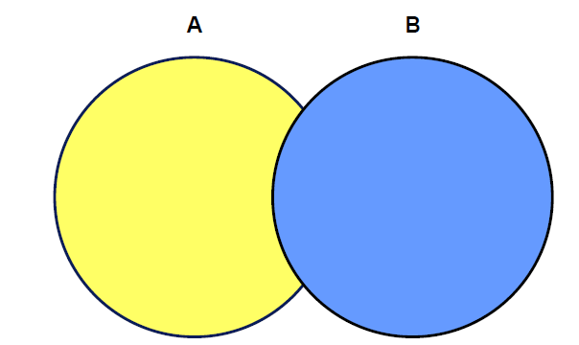

The order of SELECTs does make a difference

EXAMPLE:

Show all employees in the company (A) that - have never held a different job (stored in B).

- i.e. stayed in the same job

SELECT employee_id "Emp#", job_id "Job Title"

FROM employees

MINUS

SELECT employee_id, job_id

FROM job_history

ORDER BY 1, 2

Emp# Job Title

---------- ----------

100 AD_PRES

101 AD_VP

102 AD_VP

103 IT_PROG

104 IT_PROG

107 IT_PROG

124 ST_MAN

141 ST_CLERK

142 ST_CLERK

143 ST_CLERK

144 ST_CLERK

149 SA_MAN

174 SA_REP

178 SA_REP

201 MK_MAN

202 MK_REP

205 AC_MGR

206 AC_ACCOUNT

18 rows selected. 🡸 **20 rows in employees, less the 0 duplicates -2 in the intersect**

Matching SELECT statements

8-25

EXAMPLE 1:

Display all employees their job id and salary.

What are the problems?

Employees have several jobs and to display all the jobs requires a join to the job_history table

But … the job_history table does not have salary

SELECT employee_id, job_id, salary

Matching columns

If no salary will show 0

FROM employees

UNION

SELECT employee_id, job_id, 0

FROM job_history;

EMPLOYEE_ID JOB_ID SALARY

----------- ---------- ----------

100 AD_PRES 24000

101 AC_ACCOUNT 0

101 AC_MGR 0

101 AD_VP 17000

102 AD_VP 17000

102 IT_PROG 0

103 IT_PROG 9000

104 IT_PROG 6000

107 IT_PROG 4200

114 ST_CLERK 0

122 ST_CLERK 0

124 ST_MAN 5800

141 ST_CLERK 3500

142 ST_CLERK 3100

143 ST_CLERK 2600

144 ST_CLERK 2500

149 SA_MAN 10500

174 SA_REP 11000

176 SA_MAN 0

176 SA_REP 0

176 SA_REP 8600

178 SA_REP 7000

200 AC_ACCOUNT 0

200 AD_ASST 0

200 AD_ASST 4400

201 MK_MAN 13000

201 MK_REP 0

202 MK_REP 6000

205 AC_MGR 12000

206 AC_ACCOUNT 8300

30 rows 🡸 20 + 10 - 0

EXAMPLE 2:

Display department ID, location ID and hire date for all members

Need location_id from departments but it doesn't have a date to match with

Need hire_date from employees but it doesn't have a location_id in employees

***Because the expressions in the SELECT lists of the queries must match in number***,

- use the dummy columns and the data type conversion functions to comply with this rule.

You must match the data type when columns do not exist in one or the other table

- use the TO_CHAR or any other conversion function to get the same data type

SELECT department_id, TO_NUMBER (null) as location, hire_date

FROM employees

UNION

Note the location because TO_NUMBER (null) does not make a good column heading

SELECT department_id, location_id, TO_DATE (null)

FROM departments;

DEPARTMENT_ID LOCATION HIRE_DATE

------------- ---------- ---------

10 1700

10 17-SEP-87

20 1800

20 17-FEB-96

20 17-AUG-97

50 1500

50 17-OCT-95

50 29-JAN-97

From a diffeent example. Notice that the blanks are nulls

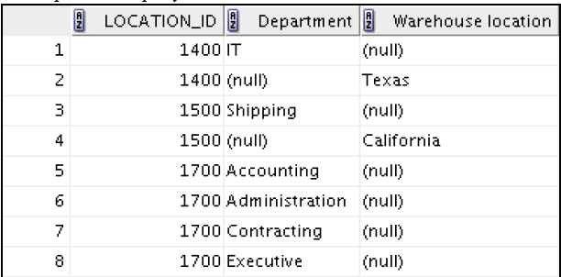

50 15-MAR-98

50 09-JUL-98

50 16-NOV-99

60 1400

60 03-JAN-90

60 21-MAY-91

60 07-FEB-99

80 2500

80 11-MAY-96

80 24-MAR-98

80 29-JAN-00

90 1700

90 17-JUN-87

90 21-SEP-89

90 13-JAN-93

110 1700

110 07-JUN-94

190 1700

24-MAY-99

27 rows selected.

Rules for ORDER BY

8-28

• The ORDER BY clause can appear only once at the end of the compound query. Same as before – at the end

• Component queries cannot have individual ORDER BY clauses.

Follows the only once rule above

• The ORDER BY clause recognizes only the columns of the first SELECT query.

• By default, the first column of the first SELECT query is used to sort the output in an ascending order.

Need an ORDER BY to force a different sort

SELECT employee_id, job_id, salary

FROM employees

UNION

SELECT employee_id, job_id, 0

FROM job_history

ORDER BY 2; 🡸 to change default of sorting on employee-Id